Customer Requirements Specification

**Speed Bump MobileApp**

**ـــــــــــــــــــــــــــــــــــــــــــــــــــــــــــــــــــــــــــــــــــــــــــــــــــــــــــــــــــــــــــــــــــــــــــــــــــــــــــــــــــــــــــــــــــــــــــــــــــــــــــــــــــــــــــــــــــــــــــــــــــــــ**

**Table of Contents**

Document Status: ………………………………………………………………...1

Document History: ………………………………………………………………..1

Reference Document: …………………………………………………………....2

Project Description: ……………………………………………………………....3

# **Document Status:**

|  |  |
| --- | --- |
| **Name** | PO_SB_CRS_MobileApp |
| **Version** | V1.1 |
| **Status** | Proposed |
| **Author** | Noorhan Hatem |
| **Date** | [31/10/2022] |

## Document History:

|  |  |  |  |
| --- | --- | --- | --- |
| **Version** | **Author** | **Date** | **Change** |
| 1.0 | Marwa Mansour | [29/10/2022] | * Initial Creation |
| 1.0 | Noorhan Hatem | [31/10/2022] | * Edit Some requirements |

### 

### Reference Document:

|  |  |  |  |
| --- | --- | --- | --- |
| **Ref.number** | **Doc.Name** | **Version** | **Status** |
| 1 | PO_SB_CR_SpeedBumps | 1.1 | Released |

#### 

#### Project Description:

Definition:

An application through which the user can be notified about the coming speed

bumps on the road and the remaining distance between the car and the bump.

Features:

* Different pricing plans.
* Users can control the ride.
* Alerting the user with the coming speed bumps.
* Asking for permission.
* Monitor HW device.
* Technical Issues reporting.

Key Elements:

● The mobile app shall contain a basic plan.

● The mobile app shall contain a premium plan.

● The mobile app shall contain the option to start and end the ride.

● The app shall alert the user with the coming bumps.

● The app shall alert the user with the remaining distance till the bump.

● The app shall save the bump’s location on the user’s GPS screen.

● Application shall guarantee user permission to use Bluetooth, location, etc.

● In the premium plan, the app shall ask the user for his/her permission to

save the bumps on the ride.

● Application shall be notified by the embedded device’s issues and status.

● Users can report any technical issue.

System Context:

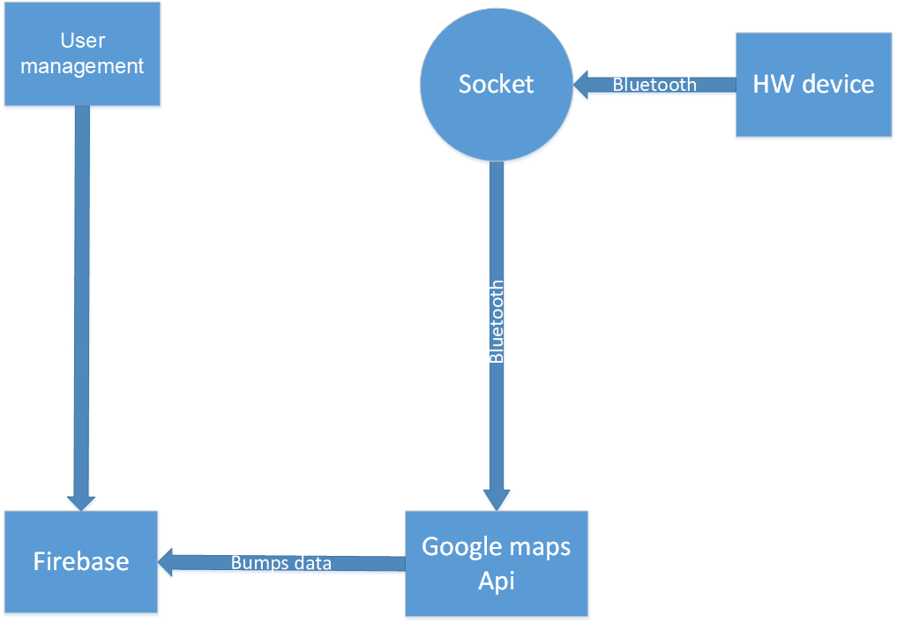

CRS Requirements:

| **Req_ID** | PO_SB_CRS_**001**_V1.0 | | **Covers** | PO_SB_ CR_MobileApp_**001**-V1.1 | |
| --- | --- | --- | --- | --- | --- |
| **Description** | If the user chooses the pasic plan , he/she shall pay for monthly or yearly subscription. | | | | |
| **Req_ID** | PO_SB_CRS_**002**_V1.0 | **Covers** | | | PO_SB_ CR_MobileApp_**001**-V1.1 |
| **Description** | If the user chooses the basic plan ,the detected speed bumps shall be based on the historical data of other users(the premium plan users). | | | | |
| **Req_ID** | PO_SB_CRS_**003**_V1.0 | **Covers** | | | PO_SB_CR_MobileApp_**002**-V1.1 |
| **Description** | If the user chooses the premium plan ,he/she shall buy the hardware detection device . | | | | |
| **Req_ID** | PO_SB_CRS_**004**_V1.0 | **Covers** | | | PO_SB_CR_MobileApp_**003**-V1.1 |
| **Description** | The user shall add his/her destination to use the “Start the ride “button ,then the GPS screen appears. | | | | |
| **Req_ID** | PO_SB_CRS_**005**_V1.0 | **Covers** | | | PO_SB_CR_MobileApp_**003**-V1.1 |
| **Description** | The user shall end the ride by using the “End the ride” button. | | | | |
| **Req_ID** | PO_SB_CRS_**006**_V1.0 | **Covers** | | | PO_SB_CR_MobileApp_**004**-V1.1 |
| **Description** | In the premium plan , the app shall voice notify the users about the detected speed bumps on the road. | | | | |
| **Req_ID** | PO_SB_CRS_**007**_V1.0 | **Covers** | | | PO_SB_CR_MobileApp_**004**-V1.1 |
| **Description** | In the basic plan ,, the app shall voice notify the users about all saved speed bumps on the road in the historical data. | | | | |
| **Req_ID** | PO_SB_CRS_**008**_V1.0 | **Covers** | | | PO_SB_CR_MobileApp_**005**-V1.1 |
| **Description** | The app shall voice notify the user with the remaining distance till the coming detected bump. | | | | |
| **Req_ID** | PO_SB_CRS_**009**_V1.0 | **Covers** | | PO_SB_CR_MobileApp_**006**-V1.1 | |
| **Description** | In premium plan, the app shall save the data of the bump’s location on the screen to help the user know the location. | | | | |
| **Req_ID** | PO_SB_CRS_**010**_V1.0 | **Covers** | | PO_SB_CR_MobileApp_**006**-V1.1 | |
| **Description** | In the basic plan, the app shall show the bump’s location from the saved data from the premium users. | | | | |
| **Req_ID** | PO_SB_CRS_**011**_V1.0 | **Covers** | | PO_SB_CR_MobileApp_**007**-V1.1 | |
| **Description** | The app shall ask the user for his/her permission to access the Bluetooth to connect with the hardware. | | | | |
| **Req_ID** | PO_SB_CRS_**012**_V1.0 | **Covers** | | PO_SB_CR_MobileApp_**007**-V1.1 | |
| **Description** | In the premium plan ,the app shall ask the user for his/her permission to access the location of the user to open the map for him/her. | | | | |
| **Req_ID** | PO_SB_CRS_**013**_V1.0 | **Covers** | | PO_SB_CR_MobileApp_**008**-V1.1 | |
| **Description** | At the end of the ride the app shall ask the user to save the data of the bumps on the ride. | | | | |
| **Req_ID** | PO_SB_CRS_**014**_V1.0 | **Covers** | | PO_SB_CR_MobileApp_**008**-V1.1 | |
| **Description** | The saved data will appear on the map so the user shall know the location of the saved bumps before starting the ride. | | | | |
| **Req_ID** | PO_SB_CRS_**015**_V1.0 | **Covers** | | PO_SB_CR_MobileApp_**009**-V1.1 | |
| **Description** | The status of the hardware shall appear in the application. | | | | |
| **Req_ID** | PO_SB_CRS_**016**_V1.0 | **Covers** | | PO_SB_CR_MobileApp_**009**-V1.1 | |
| **Description** | If there is any issue with the embedded device the application shall be notified. | | | | |
| **Req_ID** | PO_SB_CRS_**017**_V1.0 | **Covers** | | PO_SB_CR_MobileApp_**010**-V1.1 | |
| **Description** | The user will be able to report any issue that occurs. | | | | |